| Cybersecurity |
| --- |
| Penetration Test Report |

Rekall Corporation

Penetration Test Report

**Student Note: Complete all sections highlighted in yellow.**

# 

## Confidentiality Statement

This document contains confidential and privileged information from Rekall Inc. (henceforth known as Rekall). The information contained in this document is confidential and may constitute inside or non-public information under international, federal, or state laws. Unauthorized forwarding, printing, copying, distribution, or use of such information is strictly prohibited and may be unlawful. If you are not the intended recipient, be aware that any disclosure, copying, or distribution of this document or its parts is prohibited.

Table of Contents

Confidentiality Statement 2

Contact Information 4

Document History 4

Introduction 5

Assessment Objective 5

Penetration Testing Methodology 6

Reconnaissance 6

Identification of Vulnerabilities and Services 6

Vulnerability Exploitation 6

Reporting 6

Scope 7

Executive Summary of Findings 8

Grading Methodology 8

Summary of Strengths 9

Summary of Weaknesses 9

Executive Summary Narrative 10

Summary Vulnerability Overview 13

Vulnerability Findings 14

# 

## Contact Information

| **Company Name** | Team 10 LLC |
| --- | --- |
| **Contact Name** | Samir Anwar |
| **Contact Title** | Penetration Tester |

## 

## Document History

| **Version** | **Date** | **Author(s)** | **Comments** |
| --- | --- | --- | --- |
| 001 | 10/30/2023 | Samir Anwar | Performed pen testing techniques against totalrekall web app. |
| 002 | 10/31/2023 | Samir Anwar | Performed pen testing techniques against totalrekall linux servers. |
| 003 | 11/02/2023 | Samir Anwar | Performed pen testing techniques against totalrekall windows servers. |

# 

## Introduction

In accordance with Rekall policies, our organization conducts external and internal penetration tests of its networks and systems throughout the year. The purpose of this engagement was to assess the networks’ and systems’ security and identify potential security flaws by utilizing industry-accepted testing methodology and best practices.

For the testing, we focused on the following:

* Attempting to determine what system-level vulnerabilities could be discovered and exploited with no prior knowledge of the environment or notification to administrators.
* Attempting to exploit vulnerabilities found and access confidential information that may be stored on systems.
* Documenting and reporting on all findings.

All tests took into consideration the actual business processes implemented by the systems and their potential threats; therefore, the results of this assessment reflect a realistic picture of the actual exposure levels to online hackers. This document contains the results of that assessment.

### Assessment Objective

The primary goal of this assessment was to provide an analysis of security flaws present in Rekall’s web applications, networks, and systems. This assessment was conducted to identify exploitable vulnerabilities and provide actionable recommendations on how to remediate the vulnerabilities to provide a greater level of security for the environment.

We used our proven vulnerability testing methodology to assess all relevant web applications, networks, and systems in scope.

Rekall has outlined the following objectives:

Table 1: Defined Objectives

| **Objective** |
| --- |
| Find and exfiltrate any sensitive information within the domain. |
| Escalate privileges. |
| Compromise several machines. |

# 

## Penetration Testing Methodology

### Reconnaissance

### 

We begin assessments by checking for any passive (open source) data that may assist the assessors with their tasks. If internal, the assessment team will perform active recon using tools such as Nmap and Bloodhound.

### Identification of Vulnerabilities and Services

We use custom, private, and public tools such as Metasploit, hashcat, and Nmap to gain perspective of the network security from a hacker’s point of view. These methods provide Rekall with an understanding of the risks that threaten its information, and also the strengths and weaknesses of the current controls protecting those systems. The results were achieved by mapping the network architecture, identifying hosts and services, enumerating network and system-level vulnerabilities, attempting to discover unexpected hosts within the environment, and eliminating false positives that might have arisen from scanning.

### Vulnerability Exploitation

Our normal process is to both manually test each identified vulnerability and use automated tools to exploit these issues. Exploitation of a vulnerability is defined as any action we perform that gives us unauthorized access to the system or the sensitive data.

### Reporting

Once exploitation is completed and the assessors have completed their objectives, or have done everything possible within the allotted time, the assessment team writes the report, which is the final deliverable to the customer.

# 

## Scope

Prior to any assessment activities, Rekall and the assessment team will identify targeted systems with a defined range or list of network IP addresses. The assessment team will work directly with the Rekall POC to determine which network ranges are in-scope for the scheduled assessment.

It is Rekall’s responsibility to ensure that IP addresses identified as in-scope are actually controlled by Rekall and are hosted in Rekall-owned facilities (i.e., are not hosted by an external organization). In-scope and excluded IP addresses and ranges are listed below.

# 

# 

## Executive Summary of Findings

## 

### Grading Methodology

Each finding was classified according to its severity, reflecting the risk each such vulnerability may pose to the business processes implemented by the application, based on the following criteria:

**Critical**: Immediate threat to key business processes.

**High**: Indirect threat to key business processes/threat to secondary business processes.

**Medium**: Indirect or partial threat to business processes.

**Low**: No direct threat exists; vulnerability may be leveraged with other vulnerabilities.

Informational: No threat; however, it is data that may be used in a future attack.

As the following grid shows, each threat is assessed in terms of both its potential impact on the business and the likelihood of exploitation:

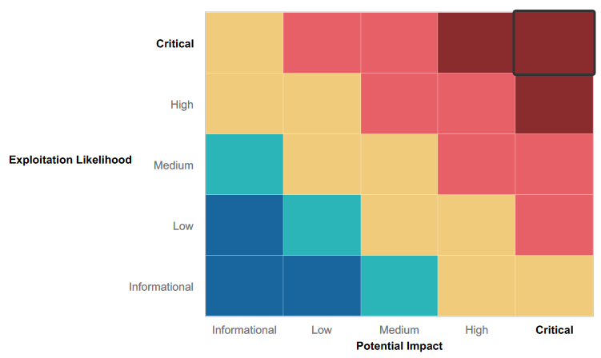

### 

### Summary of Strengths

While the assessment team was successful in finding several vulnerabilities, the team also recognized several strengths within Rekall’s environment. These positives highlight the effective countermeasures and defenses that successfully prevented, detected, or denied an attack technique or tactic from occurring.

* Input Validation - Certain fields do not allow for basic JavaScript payloads enclosed in basic <script></script> tags. Advanced XSS is required in some cases.
* Not vulnerable to basic SQL injection tactics.
* Robots.txt file disallows web crawlers from viewing admin-level data.

### Summary of Weaknesses

We successfully found several critical vulnerabilities that should be immediately addressed in order to prevent an adversary from compromising the network. These findings are not specific to a software version but are more general and systemic vulnerabilities.

* Input Validation - Most fields allow for XSS via script injection.
* VR Planner page vulnerable to multiple file inclusion exploits.
* Admin credentials found in developer tools tab.

## Executive Summary

**Day 1: October 30th, 2023 - Probing Totalrekall Web App**

Vulnerability 1: Reflected XSS vulnerability detected on welcome.php page

* Exploit method: JavaScript injection - <script>alert(“Hi! You’ve been hacked.”)</script>

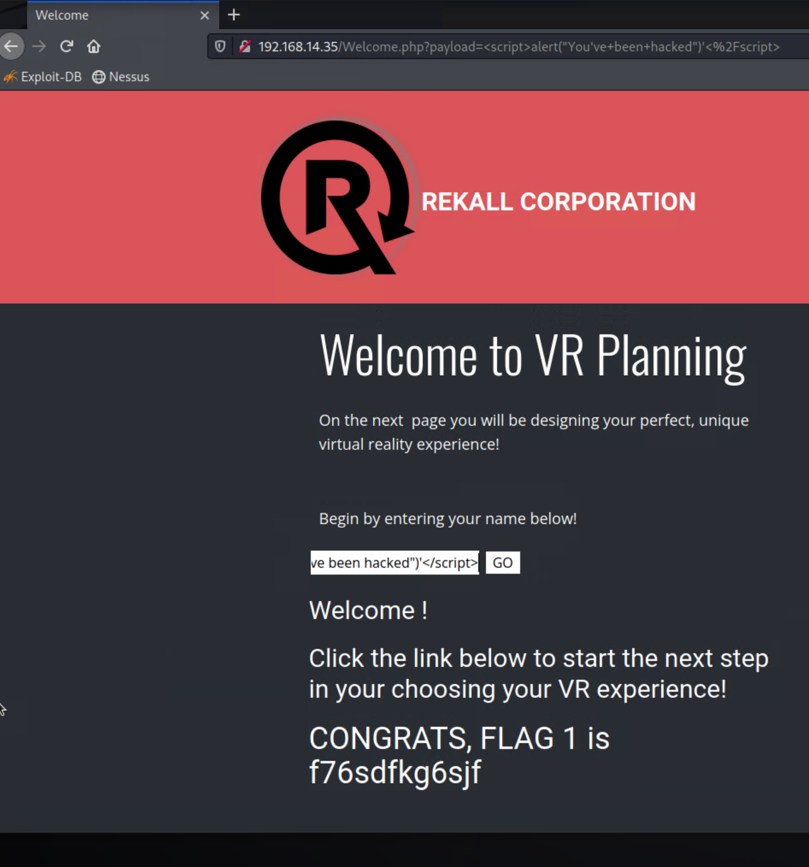

Vulnerability 2: Advanced reflected XSS injection vulnerability detected on memory-planner.php.

* Exploit method: Modifying script tags in payload i.e., <HELLscriptO>alert(...);</HELLscriptO>



Vulnerability 3: Stored XSS injection vulnerability detected in comments.php page.

* Exploit Method: JavaScript Payload <script>alert(“Hello There”);</script>

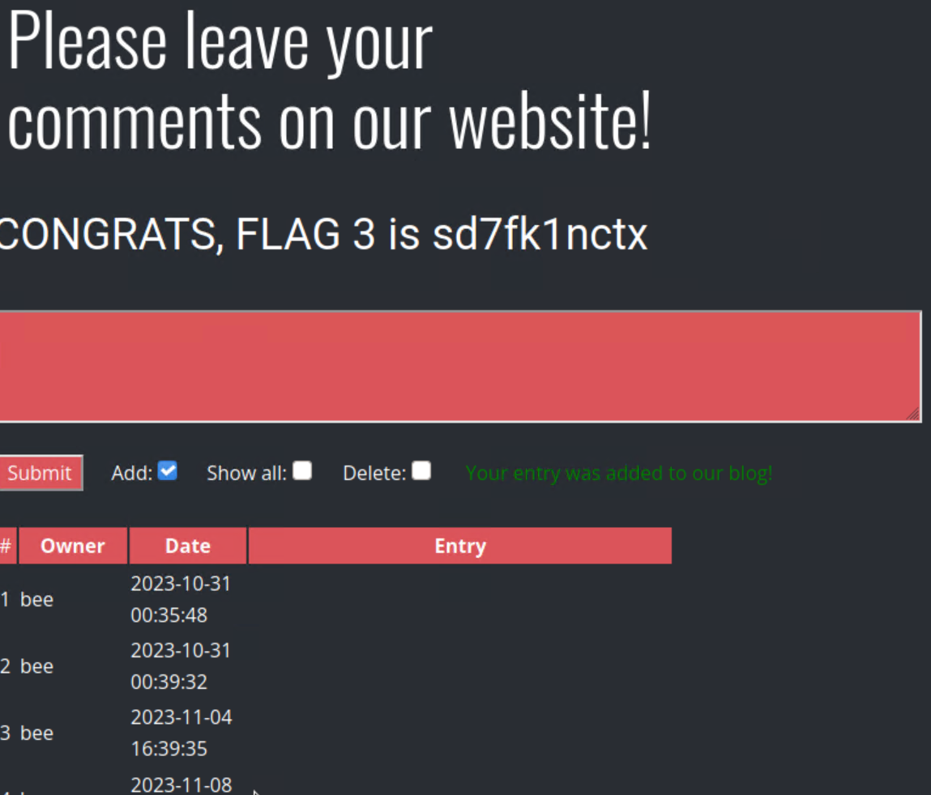

## Vulnerability 4: LFI vulnerability detected in second upload field in memory-planner.php page.

* Exploit: Uploading PHP script with the following code:

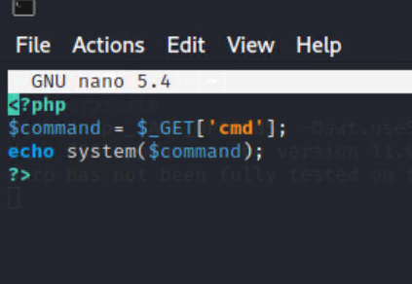

## 

## Vulnerability 5: Advanced LFI vulnerability detected in memory-planner.php page in second upload field.

* Exploit: Renaming script.php > script.jpg.php to bypass image input validation.

## 

Vulnerability 6: Used Developer tools to inspect HTML structure of the login page to reveal admin credentials - dougquiad:kuato

* Location: 192.168.14.35/Login.php
* Vulnerability: Data Exposure
* Exploit used: Used Developer tools to inspect HTML structure of the login page to reveal admin credentials - dougquiad:kuato

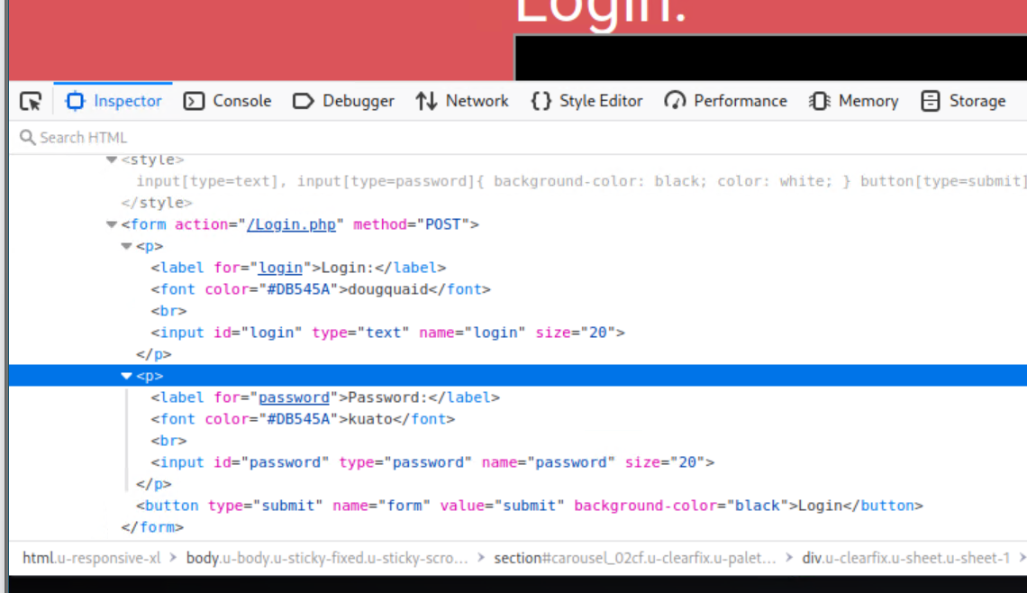

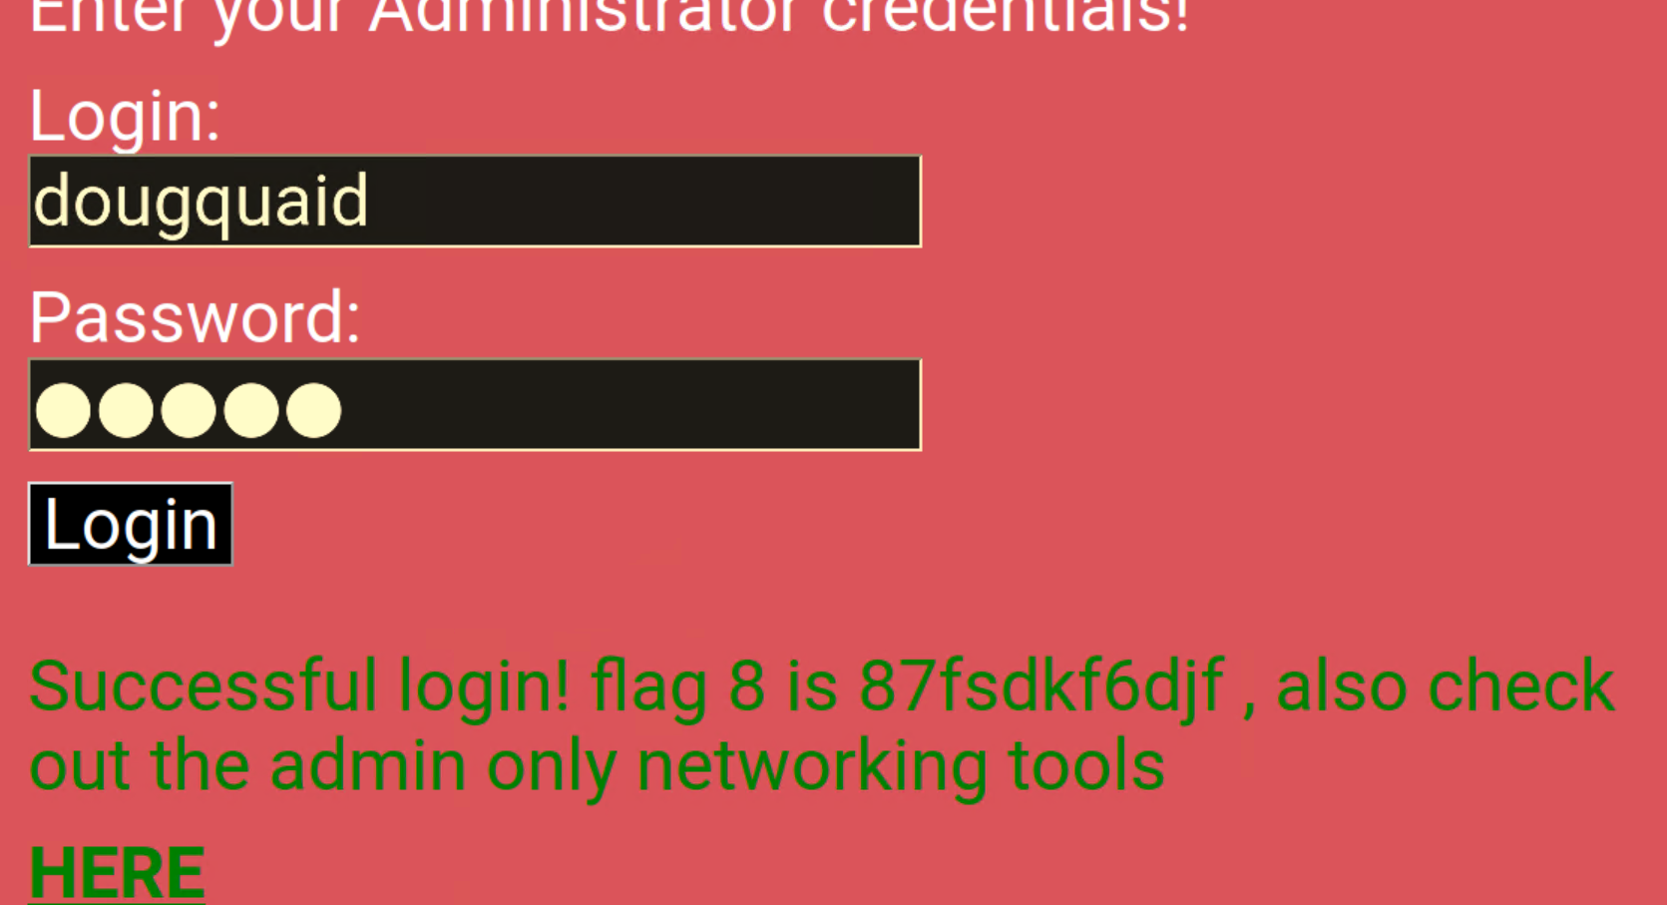

Vulnerability 7: Command Injection Vulnerability detected on networking.php page. Able to view information on type of SIEM, Firewall, and Load balancers used in connection to the website.

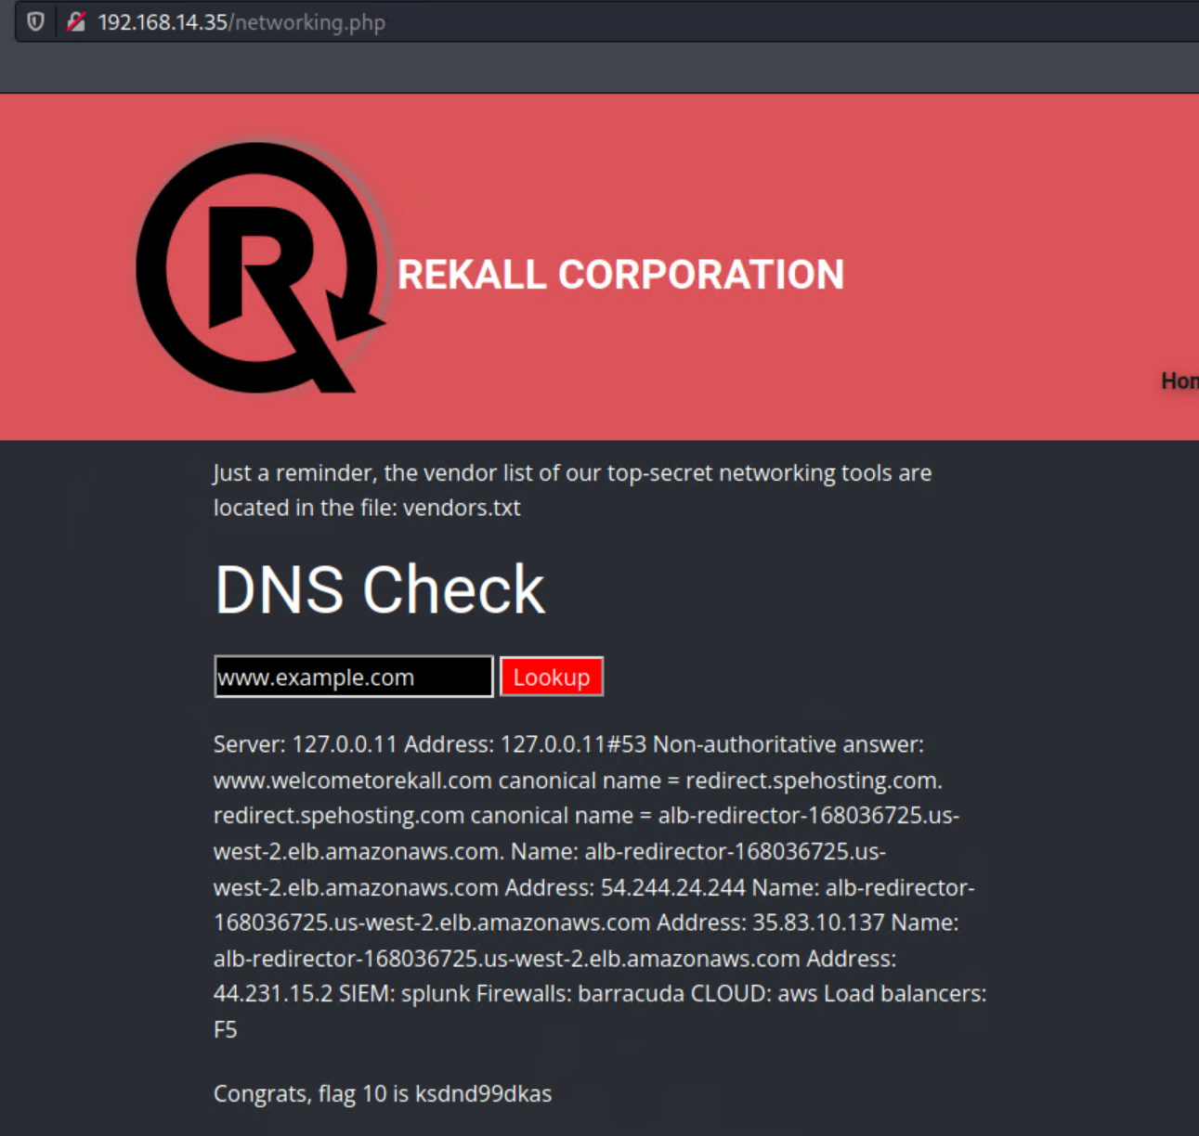

Vulnerability 8: Determined SQL injection vulnerability on the login page of totalrekall website. Unsuccessful in determining the correct payload to inject.

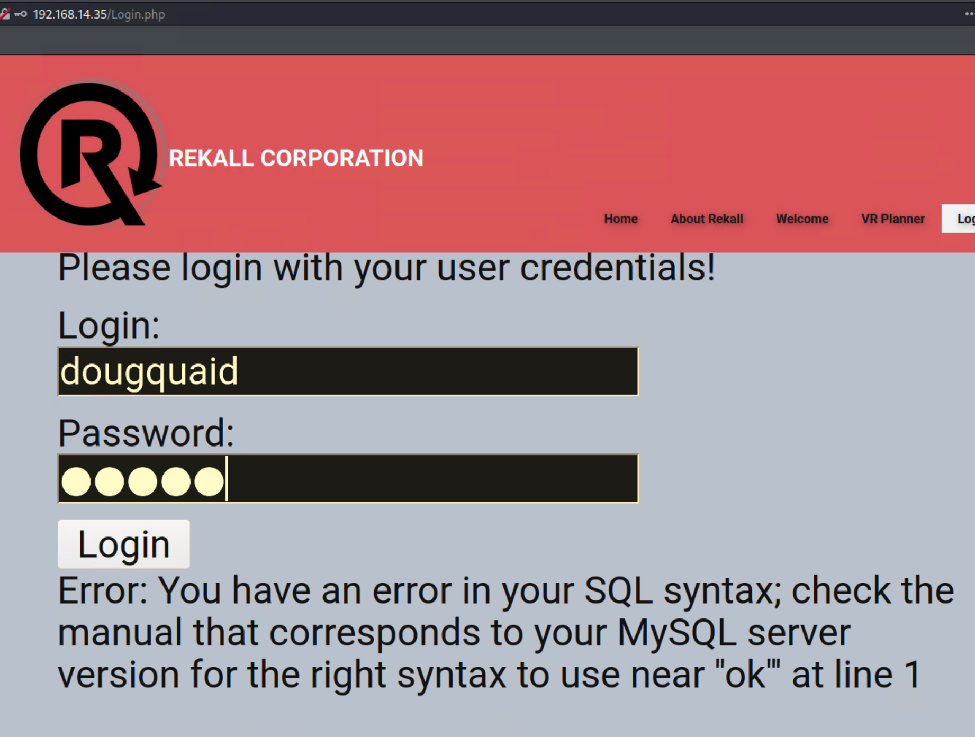dis

Vulnerability 9: Path traversal vulnerability detected on disclaimer page.

* Location: disclaimer.php?page=robots.txt
* Vulnerability: Path traversal
* Exploit: Visit the disclaimer.php page through the welcome page and change the path to ‘robots.txt’

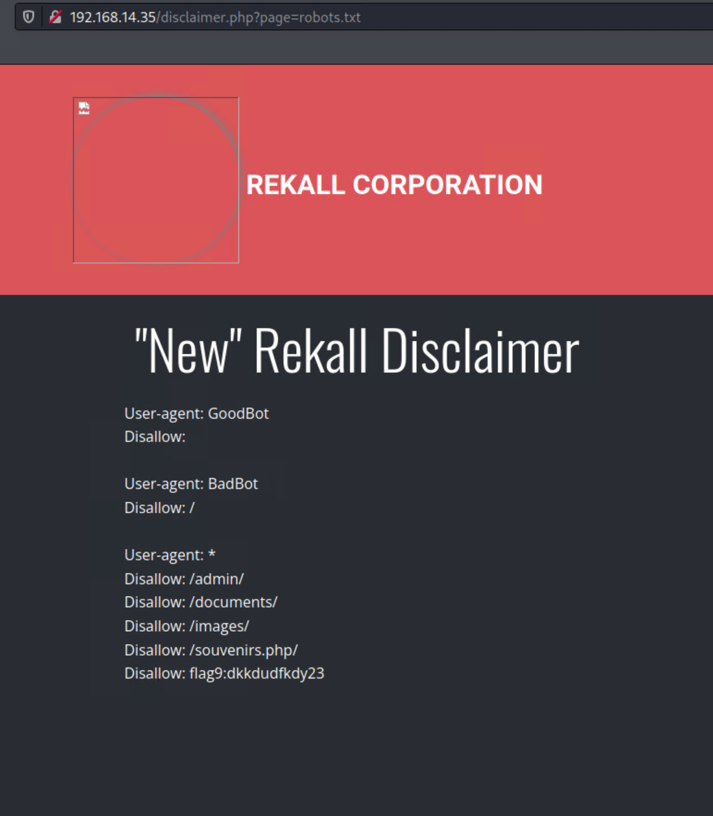

**Day 2: October 31, 2023 - Probing Linux Servers**

Vulnerability 10:

* Location: <https://centralops.net/co/DomainDossier.aspx>
* Vulnerability: PII Data Exposure
* Exploit Method: Use Domain Dossier to perform domain whois record search of ‘totalrekall.xyz’

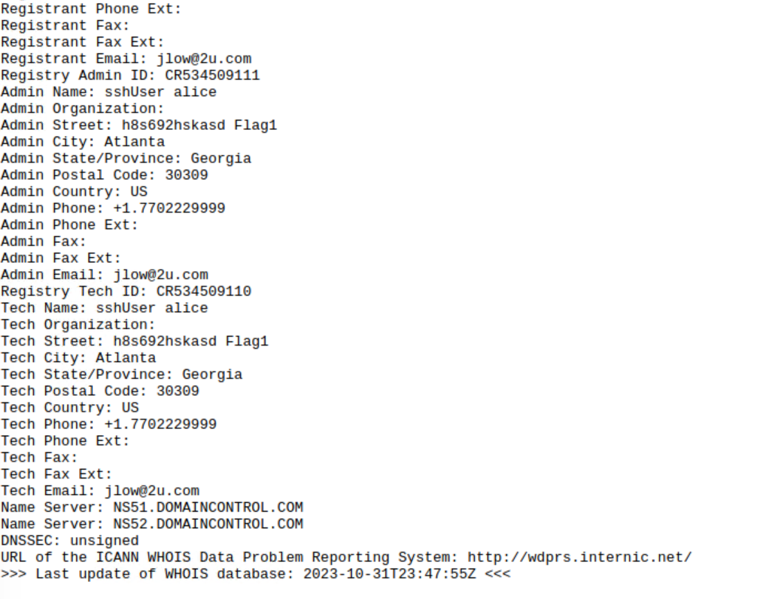

Vulnerability 11:

* Location: <https://centralops.net/co/DomainDossier.aspx>
* Vulnerability: DNS record exposure
* Exploit Method: Use Domain Dossier to perform DNS record search of ‘totalrekall.xyz’

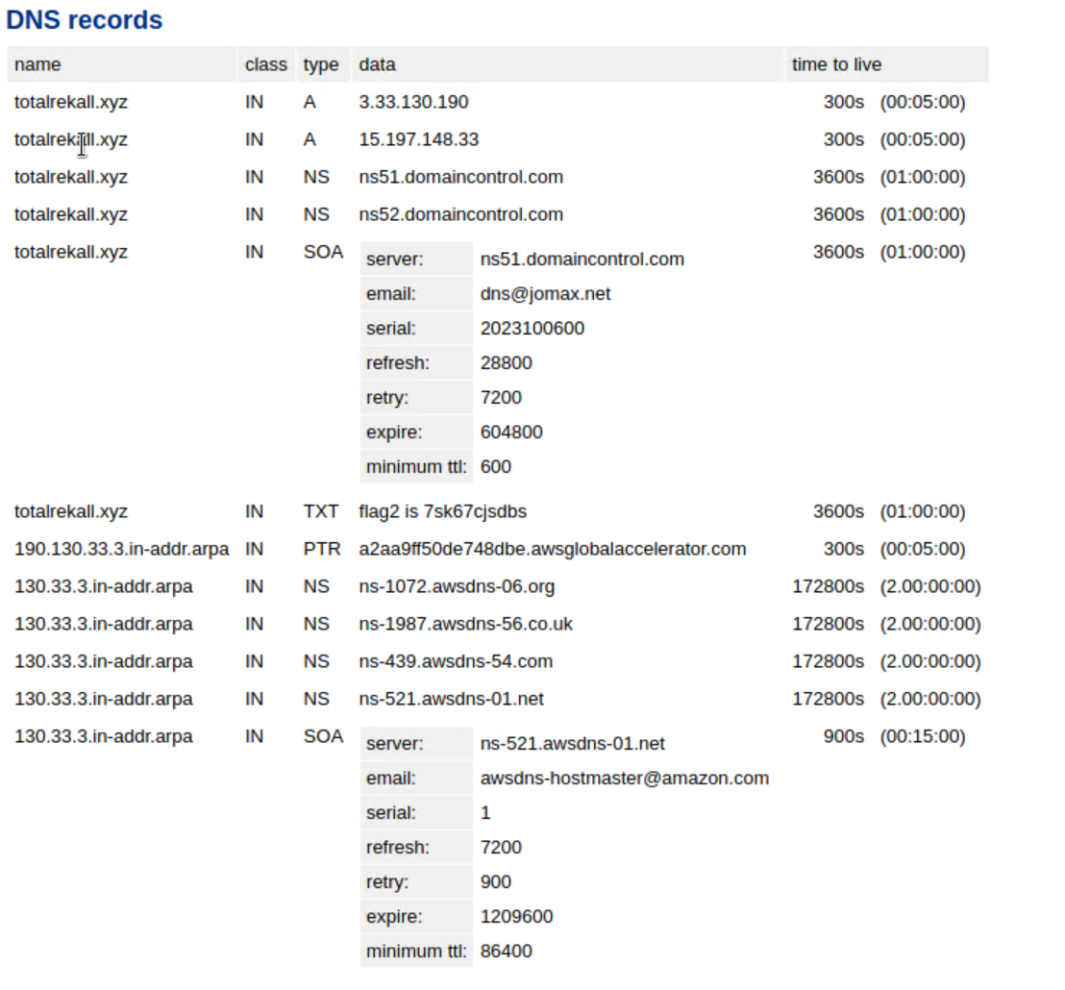

Vulnerability 12:

* Location: <https://crt.sh/?q=totalrekall.xyz>
* Vulnerability: Certificate information exposure.
* Exploit method: Use crt.sh to search certificate information on totalrekall.xyz

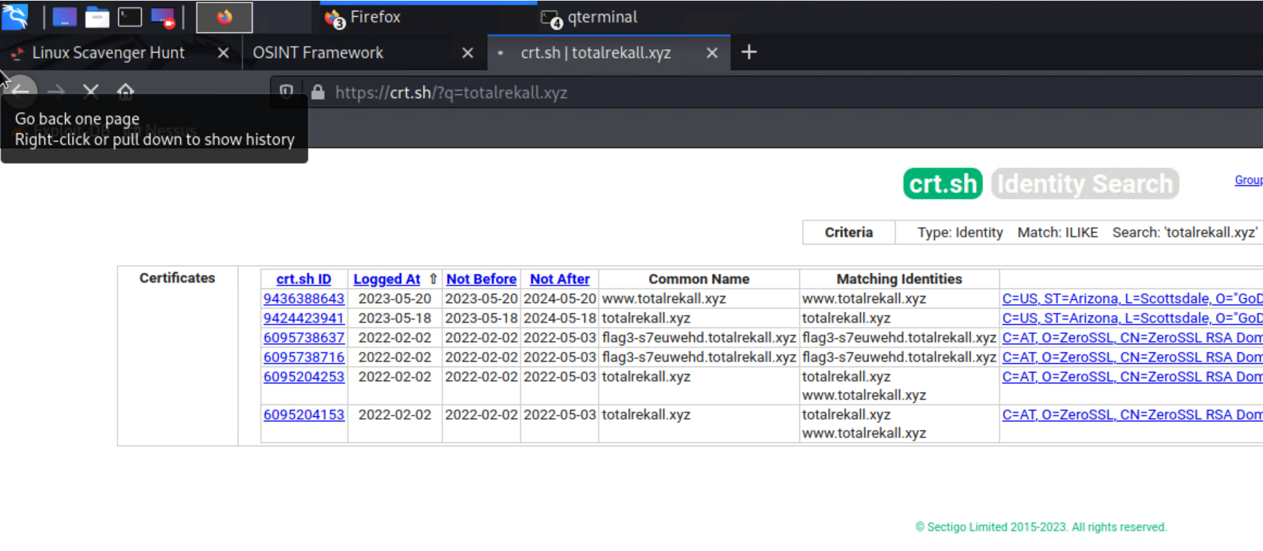

Vulnerability 13: Used msfconsole exploit module tomcat_jsp_upload_bypass to drop into a root level shell on remote host 192.168.13.10 to demonstrate RCE vulnerability:

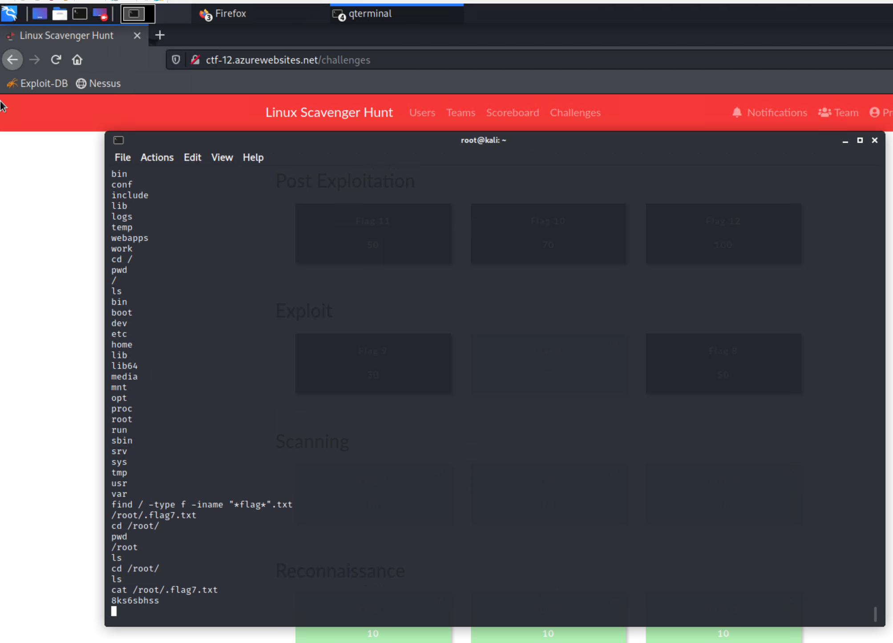

Vulnerability 14: Used msfconsole to run shellshock exploits on Rhost 192.168.13.11 and view root level directories.

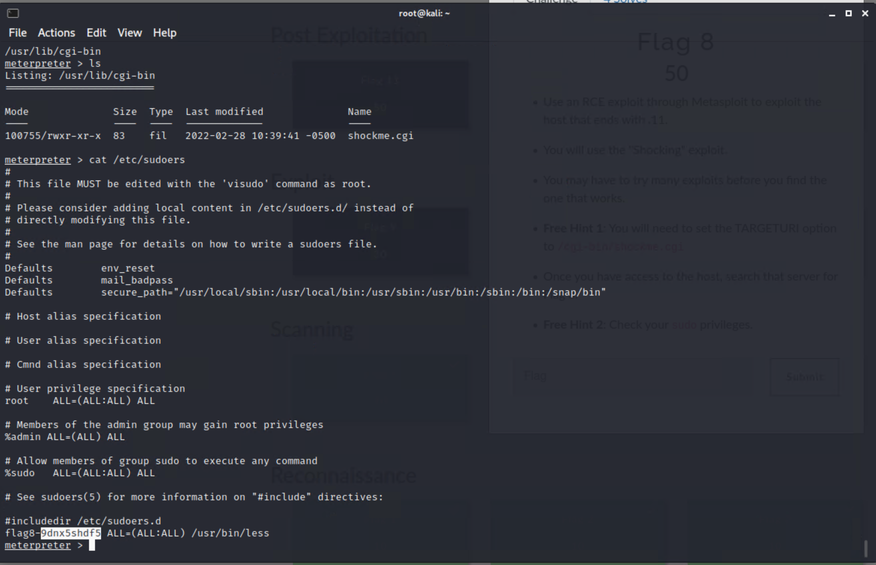

Vulnerability 15: Struts vulnerability discovered by using Nessus to determine RHOST 192.168.13.12 is vulnerable. Team 10 then opened a meterpreter shell using the appropriate exploit.

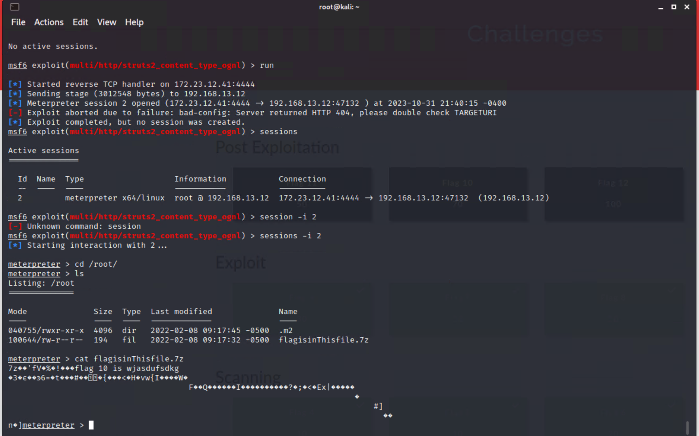

Vulnerability 16: Drupal exploit attempted on 192.168.13.13. Created meterpreter session and exfiltrated UID.

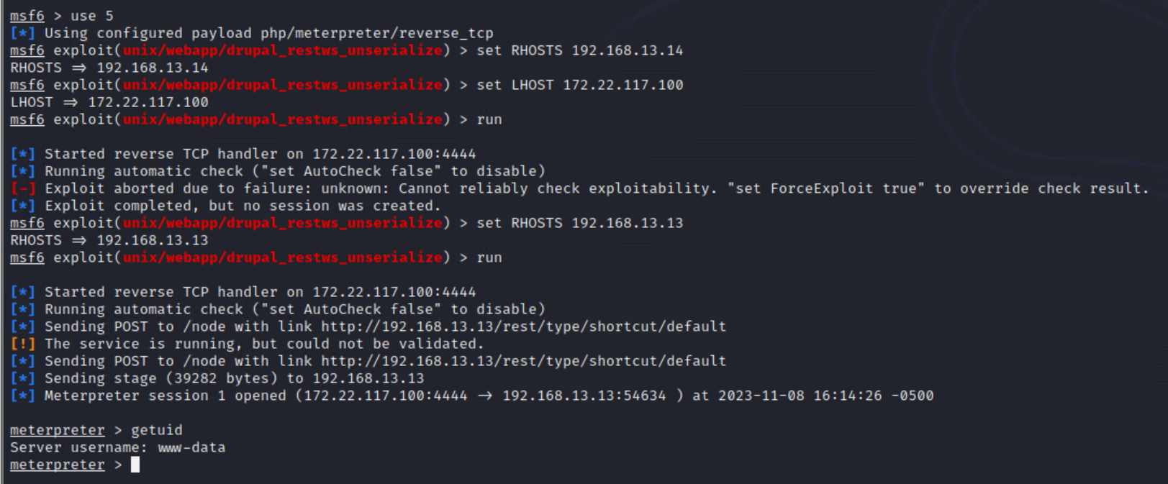

Vulnerability 17: Sudo without password. SSHed into alice user at 192.168.13.14 by password guessing. Then used sudo to extract sensitive data.

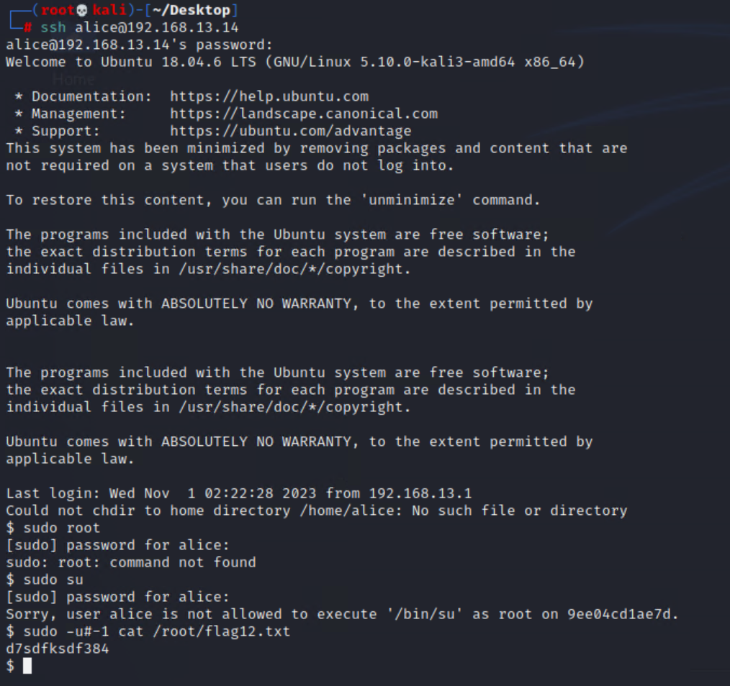

**Day 3: November 2nd, 2023 - Probing Windows Server**

Vulnerability 18: Data exposure on public github repository contains username and password hash in the following link: <https://github.com/totalrekall/site/blob/main/xampp.users>

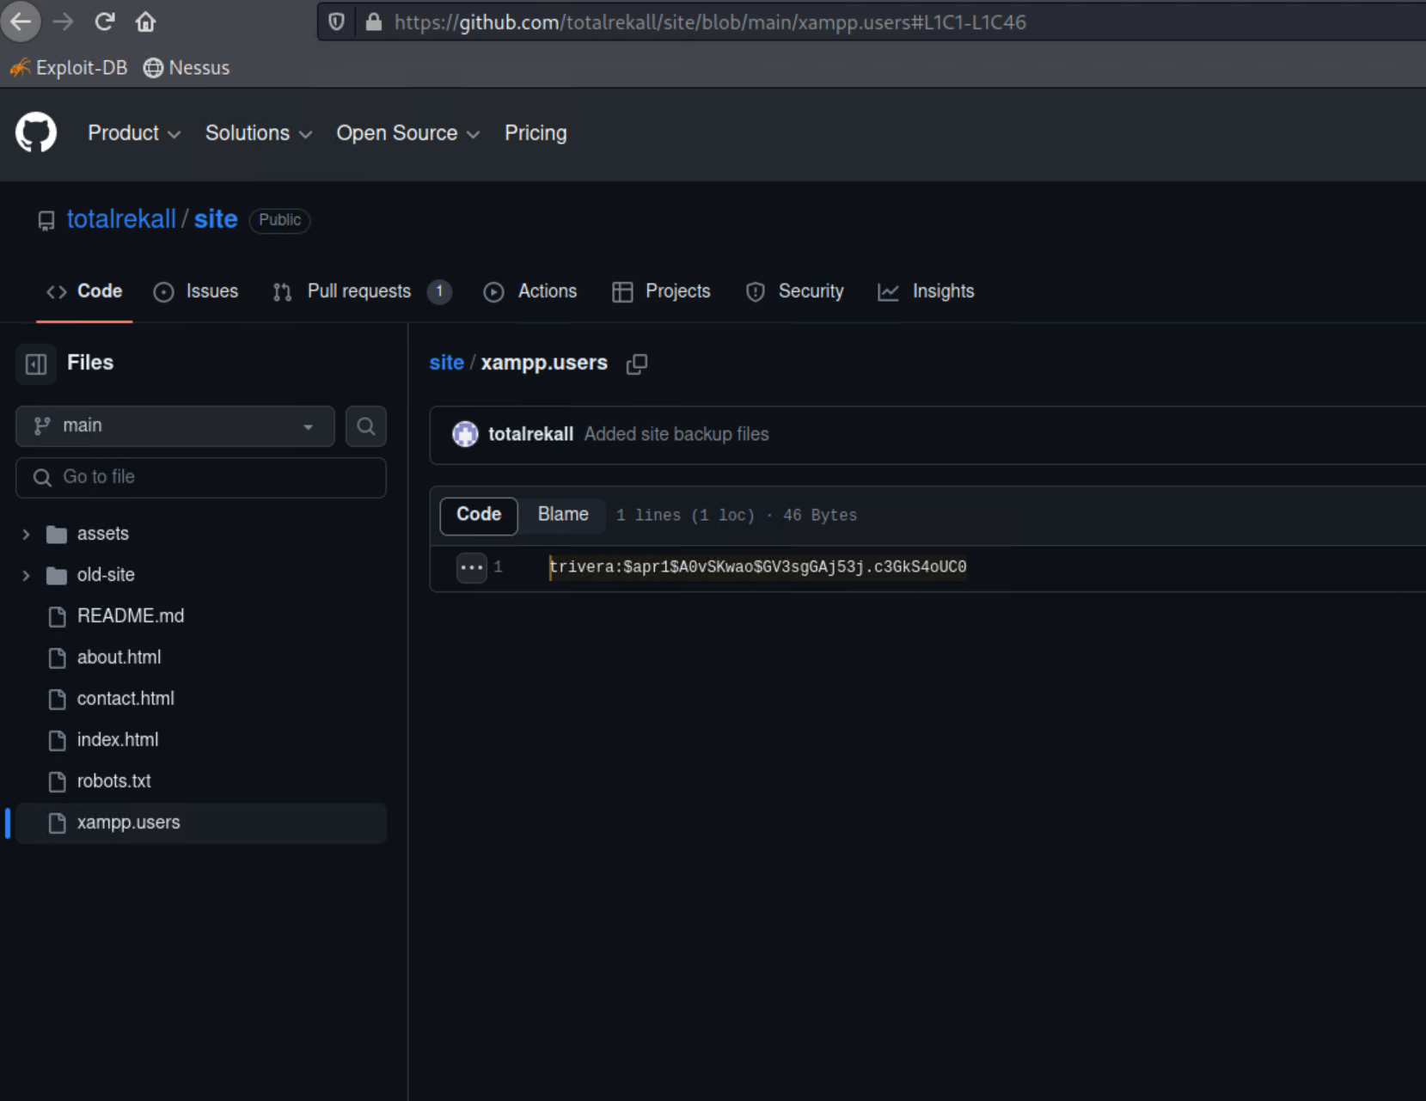

Vulnerability 19: FTP anonymous READ access is possible after running Nmap scan on Windows10 machine. Logged into FTP as anonymous and exfiltrated sensitive data.

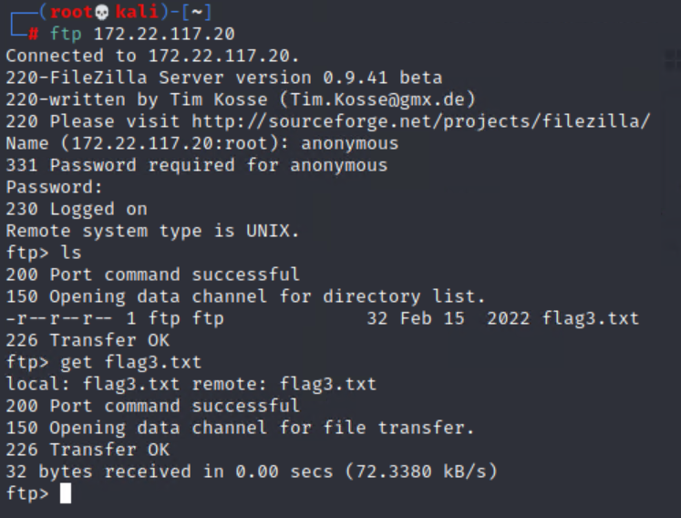

Vulnerability 20: SLMail and SMTP vulnerability detected in port scan. Used SLmail metasploit exploitation module to drop into meterpreter on the RHOST.

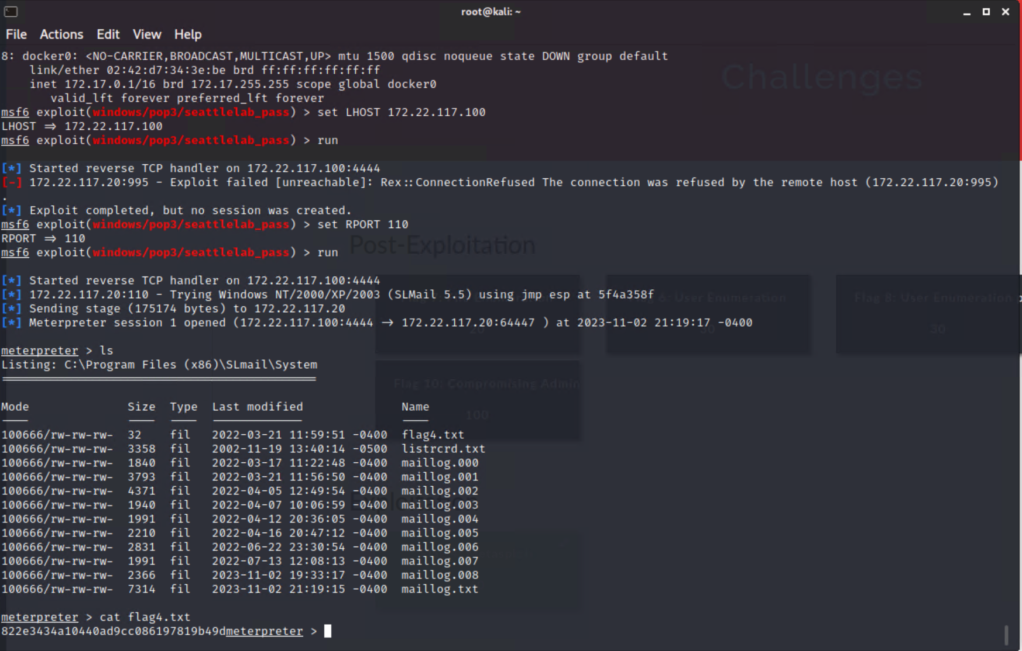

Windows post-exploitation tactic: Dropped into a SYSTEM shell after running SLMail exploit to view certain scheduled tasks on the Windows10 machine.

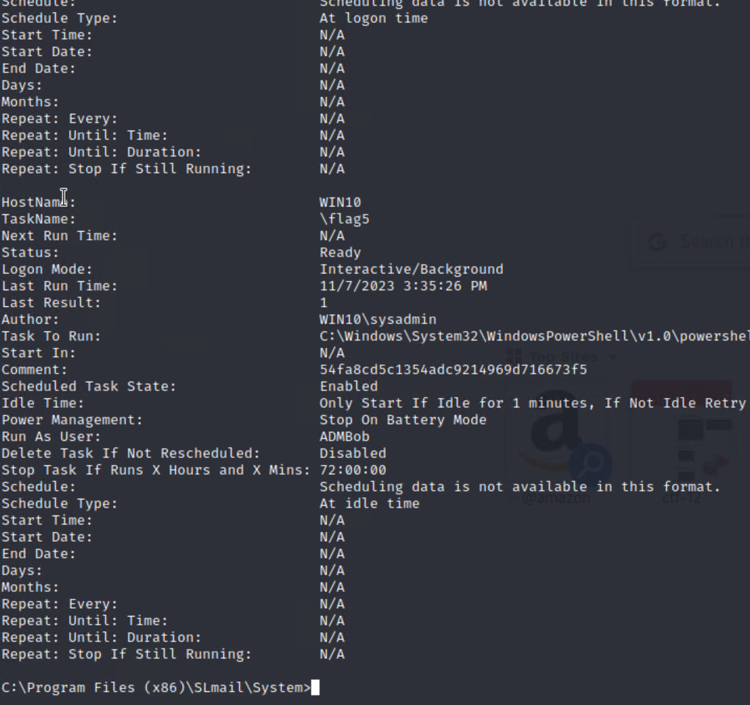

Exposed sensitive credentials via credential dumping tools in metasploit

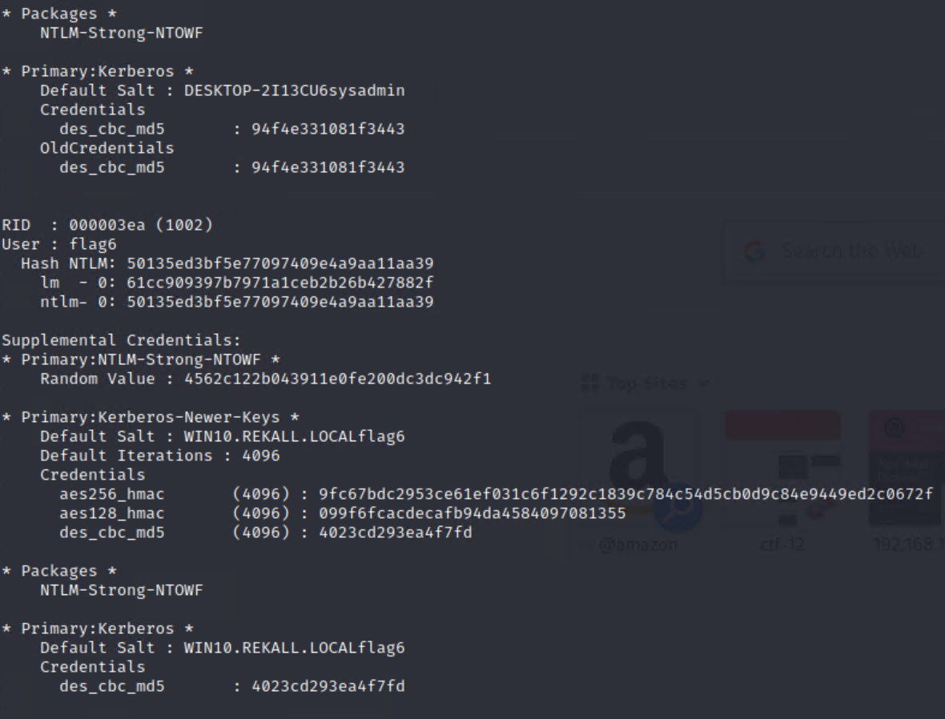

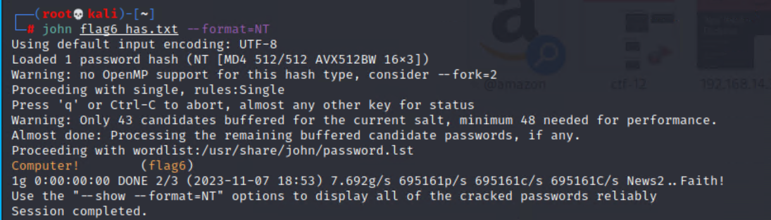

## Summary Vulnerability Overview

| **Vulnerability** | **Severity** |
| --- | --- |
| Reflected XSS | **Critical** |
| Reflected XSS (Advanced) | **Critical** |
| Stored XSS | **Critical** |
| LFI | **High** |
| LFI (Advanced) | **Critical** |
| Admin Credential Exposure | **Critical** |
| Command Injection | **Critical** |
| SQL Injection | **Critical** |
| Path Traversal | **High** |
| PII Data Exposure | **Critical** |
| DNS Record Exposure | **Critical** |
| Certificate Information Exposure | **Medium** |
| Apache Tomcat RCE | **Critical** |
| Shellshock | **Critical** |
| Struts | **Critical** |
| Drupal | **Critical** |
| SUDO/root execution without password | **Critical** |
| Public Data Exposure - Github Repo. | **Medium** |
| FTP Anonymous READ | **Critical** |
| SLMail | **Critical** |
| SYSTEM Shell Access | **Critical** |
| Credential Exposure via Credential Dumping | **Critical** |

The following summary tables represent an overview of the assessment findings for this penetration test:

| **Scan Type** | **Total** |
| --- | --- |
| Hosts | totalrekall.xyz, 192.168.13.10 - 192.168.13.14, 172.22.117.20 |
| Ports | 21, 25, 110 |

| **Exploitation Risk** | **Total** |
| --- | --- |
| **Critical** | 18 |
| **High** | 2 |
| **Medium** | 2 |
| **Low** | 0 |

## Vulnerability Findings

| **Vulnerability 1** | **Findings** |
| --- | --- |
| **Title** | Reflected XSS |
| **Type (Web app / Linux OS / WIndows OS)** | Totalrekall web app |
| **Risk Rating** | Critical |
| **Description** | Inserted basic javascript payload into welcome.php page. Injection used: <script>alert(“Hi! You’ve been hacked.”)</script> |
| **Images** |  |
| **Affected Hosts** | 192.168.14.35/Welcome.php |
| **Remediation** | Increased input validation measures. |

| **Vulnerability 2** | **Findings** |
| --- | --- |
| **Title** | Advanced Reflected XSS |
| **Type (Web app / Linux OS / WIndows OS)** | Totalrekall web app |
| **Risk Rating** | Critical |
| **Description** | Successfully attempted another reflected XSS injection with modified payload in the form of masking the script tags: <HELLscriptO>alert(...);</HELLscriptO> |
| **Images** |  |
| **Affected Hosts** | 192.168.14.35/Memory-planner.php |
| **Remediation** | Input validation to restrict any form of scripting input. |

| **Vulnerability 3** | **Findings** |
| --- | --- |
| **Title** | Stored XSS |
| **Type (Web app / Linux OS / WIndows OS)** | totalrekall web app. |
| **Risk Rating** | Critical |
| **Description** | Performed XSS injection on comments.php page of totalrekall website to generate an alert - <script>alert(“Hello There”);</script> |
| **Images** |  |
| **Affected Hosts** | 192.168..14.35/comments.php |
| **Remediation** | Implement output encoding to properly prevent user-generated content from being interpreted as HTML or JavaScript code that might execute a malicious payload. |

| **Vulnerability 4** | **Findings** |
| --- | --- |
| **Title** | Local File Inclusion |
| **Type (Web app / Linux OS / WIndows OS)** | Totalrekall web app. |
| **Risk Rating** | High |
| **Description** | Pen Testers from Team 10 LLC uploaded a basic php script file into the first upload field on the memory-planner.php page. This revealed that this particular field is not configured to accept only image files which causes critical risk to the safety of the web app. Script file shown below: |
| **Images** |  |
| **Affected Hosts** | 192.168.13.45/memory-planner.php |
| **Remediation** | FIle upload validation - Ensure that the only form of file that can be uploaded are files ending in .jpg or any other image related file. |

| **Vulnerability 5** | **Findings** |
| --- | --- |
| **Title** | Advanced Local File Inclusion |
| **Type (Web app / Linux OS / WIndows OS)** | Totalrekall web app |
| **Risk Rating** | Critical |
| **Description** | When probing the secondary upload field on the memory-planner page, pen testers from Team 10 LLC attempted uploading the same .php script file, renamed as “script.jpg.php.” This prompted a response from the web application to reveal sensitive data which can be further exploited. |
| **Images** |  |
| **Affected Hosts** | 192.168.13.45/Memory-planner.php |
| **Remediation** | File upload validation + Sanitization - Ensure only files with ‘.jpg’ format are accepted and the upload field is configured to sanitize the user input to prevent LFI attempts. |

| **Vulnerability 6** | **Findings** |
| --- | --- |
| **Title** | Admin Credential Data Exposure |
| **Type (Web app / Linux OS / WIndows OS)** | Totalrekall web application. |
| **Risk Rating** | Critical |
| **Description** | Pen Testers at Team 10 LLC used Firefox developer tools to view the HTML structure of the login.php webpage. Further analysis revealed sensitive information stored within <p> tags containing admin credentials ‘dougquaid:kuato’. Successfully logged into the admin login field with credentials and was able to view networking.php page. |
| **Images** |  |
| **Affected Hosts** | 192.168.13.45/login.php |
| **Remediation** | Immediately modify source code of totalrekall web page to remove <font> tags or remove content in between them. |

| **Vulnerability 7** | **Findings** |
| --- | --- |
| **Title** | Command Injection |
| **Type (Web app / Linux OS / WIndows OS)** | Totalrekall Web Application |
| **Risk Rating** | Critical |
| **Description** | Pen Testers at Team 10 LLC attempted various command injection techniques in order to yield sensitive data from the DNS Check field. |
| **Images** |  |
| **Affected Hosts** | 192.168.13.45/networking.php |
| **Remediation** | Remove text on networking.php page where sensitive data can be found immediately. |

| **Vulnerability 8** | **Findings** |
| --- | --- |
| **Title** | SQL Injection |
| **Type (Web app / Linux OS / WIndows OS)** | Totalrekall Web Application |
| **Risk Rating** | Critical |
| **Description** | Pen Testers at Team 10 LLC attempted various SQL injection payloads on user login fields on login.php page in order to yield sensitive data. We were unable to successfully yield any information within the web application’s database with the commands attempted. However, one of the commands attempted determined that the database is vulnerable to certain SQL injection payloads. Further testing is needed to determine specific payload for a successful exploit: |
| **Images** |  |
| **Affected Hosts** | 192.168.13.45/login.php |
| **Remediation** | Initiate input validation measures on both user and admin login fields immediately to prevent the risk of viewing any classified information. |

| **Vulnerability 9** | **Findings** |
| --- | --- |
| **Title** | Path Traversal |
| **Type (Web app / Linux OS / WIndows OS)** | Totalrekall Web Application |
| **Risk Rating** | High |
| **Description** | Pen Testers at Team 10 LLC were able to use path traversal techniques on the disclaimer.php page to view the robots.txt file. With this, it was determined that the goodbot agent is allowed to access all parts of the website/ The BadBot agent is not allowed to access any part of the website. The wildcard rule applied to all user agents not mentioned restricts access to certain directories and a particular souvenirs.php URL. |
| **Images** |  |
| **Affected Hosts** | 192.168.13.45/disclaimer.php?page=robots.txt |
| **Remediation** | Implement Access Controls immediately to restrict access to any other sensitive files and directories. In addition, ensure that only authorized users are allowed to view critical files like robots.txt |

| **Vulnerability 10** | **Findings** |
| --- | --- |
| **Title** | PII Data Exposure |
| **Type (Web app / Linux OS / WIndows OS)** | Domain Registrar |
| **Risk Rating** | Critical |
| **Description** | Penetration testers at Team 10 LLC used the Domain Dossier tool on CentralOps.net to gather information about the domain ‘totalrekall.xyz.’ The team was able to view sensitive PII regarding Admin level credentials, phone numbers, email and mailing addresses, etc. This information was exposed by performing a domain WHOIS record search of the URL. |
| **Images** |  |
| **Affected Hosts** | totalrekall.xyz |
| **Remediation** | Remove sensitive data from the associated server immediately. |

| **Vulnerability 11** | **Findings** |
| --- | --- |
| **Title** | DNS Record Exposure |
| **Type (Web app / Linux OS / WIndows OS)** | DNS Server |
| **Risk Rating** | Critical |
| **Description** | Pen Testers at Team 10 LLC use the same Domain Dossier utility to view DNS records of totalrekall.xyz. This revealed sensitive information including IP addresses,subdomains, and email addresses associated with the URL. |
| **Images** |  |
| **Affected Hosts** | totalrekall.xyz |
| **Remediation** | Remove any immediately sensitive information from the records and implement logging and monitoring mechanisms to scan for any unauthorized access attempts. |

| **Vulnerability 12** | **Findings** |
| --- | --- |
| **Title** | Certificate Information Exposure |
| **Type (Web app / Linux OS / WIndows OS)** | Totalrekall Web Application |
| **Risk Rating** | Medium |
| **Description** | Pen Testers at Team 10 LLC used crt.sh tools to view certificate validity of totalrekall.xyz. Determined that there was no valid root/intermediate certificate |
| **Images** |  |
| **Affected Hosts** | www.totalrekall.xyz |
| **Remediation** | Update the SSL certificate by contacting the Certificate Authority (CA) immediately. |

| **Vulnerability 13** | **Findings** |
| --- | --- |
| **Title** | Apache Tomcat Bypass (Remote Code Execution) |
| **Type (Web app / Linux OS / WIndows OS)** | Totalrekall Linux Server |
| **Risk Rating** | Critical |
| **Description** | Penetration testers at Team 10 LLC used metasploit exploit modules to demonstrate RCE vulnerability and drop into root session on remote host 192.168.13.10. |
| **Images** |  |
| **Affected Hosts** | 192.168.13.10, port 80 |
| **Remediation** | Apply a patch or update to Apache Tomcat installed on the remote host. In addition, consider implementing better network security measures to restrict access on vulnerable ports. |

| **Vulnerability 14** | **Findings** |
| --- | --- |
| **Title** | Shellshock Exploit |
| **Type (Web app / Linux OS / WIndows OS)** | Totalrekall Linux Server |
| **Risk Rating** | Critical |
| **Description** | Pen Testers at Team 10 LLC used metasploit to identify shellshock vulnerability and perform the appropriate exploit on RHOST 192.168.13.11. Pen testers loaded the exploit/multi/http/apache_mod_cig_bash_env_exec module, set target URI to /cgi-bin/shockme.cgi, and RHOST. Ran the exploit, opened the meterpreter shell, and successfully view sensitive information in root level directories. |
| **Images** |  |
| **Affected Hosts** | 192.168.13.11 |
| **Remediation** | Update to the most current version of BASH and assess if any other interconnected systems are vulnerable to Shellshock. |

| **Vulnerability 15** | **Findings** |
| --- | --- |
| **Title** | Struts |
| **Type (Web app / Linux OS / WIndows OS)** | Totalrekall Linux Server |
| **Risk Rating** | Critical |
| **Description** | Pen Testers at Team 10 LLC used Nessus to determine RHOST 192.168.13.12 is vulnerable to Struts exploitation. Team 10 LLC then used msfconsole to use struts exploit ‘multi/http/struts2_content_type_ognl’ to establish a meterpreter shell on the RHOST 192.168.13.12. Pen testers then extracted a special zip file containing sensitive information. |
| **Images** |  |
| **Affected Hosts** | 192.168.13.12 |
| **Remediation** | Update Apache Struts depending on the version the host is using. In addition, consider implementing a Web Application Firewall to block malicious attempts to exploit Struts. |

| **Vulnerability 16** | **Findings** |
| --- | --- |
| **Title** | Drupal Exploit |
| **Type (Web app / Linux OS / WIndows OS)** | Totalrekall Linux Server |
| **Risk Rating** | Critical |
| **Description** | Pen Testers at Team 10 LLC used MSFconsole to search for drupal exploits. Used the exploit ‘unix/webapp/drupal_restws_unserialize’ to establish a meterpreter session in RHOST 192.168.13.13. Performed the ‘getuid’ command and received ‘www-data’ as the UID for that host. |
| **Images** |  |
| **Affected Hosts** | 192.168.13.13 |
| **Remediation** | Update Drupal to the latest version that includes the latest security patches. |

| **Vulnerability 17** | **Findings** |
| --- | --- |
| **Title** | SUDO without password |
| **Type (Web app / Linux OS / WIndows OS)** | Totalrekall Linux Server |
| **Risk Rating** | Critical |
| **Description** | Pen Testers at Team 10 LLC used password guessing techniques to SSH into RHOST 192.168.13.14 using information gathered in WHOIS records. Guessed password ‘alice’, successfully executed ssh into RHOST as alice and used sudo to extract sensitive data in root level directories. |
| **Images** |  |
| **Affected Hosts** | 192.168.13.14 |
| **Remediation** | Update admin password to something more complex, and disable SSH on that port. |

| **Vulnerability 18** | **Findings** |
| --- | --- |
| **Title** | Public Data Exposure - Github Repo |
| **Type (Web app / Linux OS / WIndows OS)** | Windows OS |
| **Risk Rating** | Medium |
| **Description** | Pen Testers at Team 10 LLC used the internet to search for any public information pertaining to totalrekall. Found a public github repository containing username and password hash on <https://github.com/totalrekall/site/blob/main/xampp.users>  Then pasted contents into a .txt file and used John the Ripper tool to crack the password hash, revealing Tanya4life as password for user Trivera. |
| **Images** |  |
| **Affected Hosts** | None |
| **Remediation** | Make the Github repository private or delete it. |

| **Vulnerability 19** | **Findings** |
| --- | --- |
| **Title** | FTP Anonymous READ |
| **Type (Web app / Linux OS / WIndows OS)** | Windows OS |
| **Risk Rating** | Critical |
| **Description** | Pen Testers at Team 10 LLC performed Nmap scan on Windows10 machine: nmap -A 172.22.117.20. Revealed port 21 is open on Windows10 host and then successfully connected to Windows host using ‘ftp 172.22.117.20.’ Logged into FTP as anonymous and exfiltrated sensitive information. |
| **Images** |  |
| **Affected Hosts** | 172.22.117.20 |
| **Remediation** | Disable FTP for Windows 10 host. |

| **Vulnerability 20** | **Findings** |
| --- | --- |
| **Title** | SLMail Exploit |
| **Type (Web app / Linux OS / WIndows OS)** | Windows OS |
| **Risk Rating** | Critical |
| **Description** | Pen Testers at Team 10 LLC used Nmap scan of 172.22.117.20 to determine SLMAIL service is open via POP3 protocol on port 110. Pen testers then used MSFconsole to search for the appropriate exploit: ‘windows/pop3/seattlelab_pass.’ Loaded the exploit modules and configured the module options to create a meterpreter session on RHOST 172.22.117.20. |
| **Images** |  |
| **Affected Hosts** | 172.22.117.20 |
| **Remediation** | Disable unnecessary SLMAIL services and update to the latest version of SLMAIL for the server. |

| **Vulnerability 21** | **Findings** |
| --- | --- |
| **Title** | SYSTEM Shell Access |
| **Type (Web app / Linux OS / WIndows OS)** | Windows OS |
| **Risk Rating** | Critical |
| **Description** | Pen Testers at Team 10 LLC used a meterpreter session after running SLMAIL exploit to drop into the SYSTEM shell on Windows 10 machine and view scheduled tasks. This exploit reveals that attackers have the potential to establish a backdoor and create scheduled tasks to exfiltrate sensitive data at certain times. |
| **Images** |  |
| **Affected Hosts** | 172.22.117.20 |
| **Remediation** | Implement Least Privilege ensuring that all users and services only have read access and change login credentials frequently. |

| **Vulnerability 22** | **Findings** |
| --- | --- |
| **Title** | Credential Data Exposure |
| **Type (Web app / Linux OS / WIndows OS)** | Windows OS |
| **Risk Rating** | Critical |
| **Description** | Pen Testers at Team 10 LLC loaded the kiwi extension begin credential dumping on Windows 10 host. Using the command ‘las_dump_sam’, kiwi revealed user and password hash information. Pen testers then copied the username and hash into a txt file and used John the Ripper to crack the hash in NT format. |
| **Images** |  |
| **Affected Hosts** | 172.22.117.20 |
| **Remediation** | Implement Least Privilege ensuring that all users and services only have read access and change login credentials frequently. |